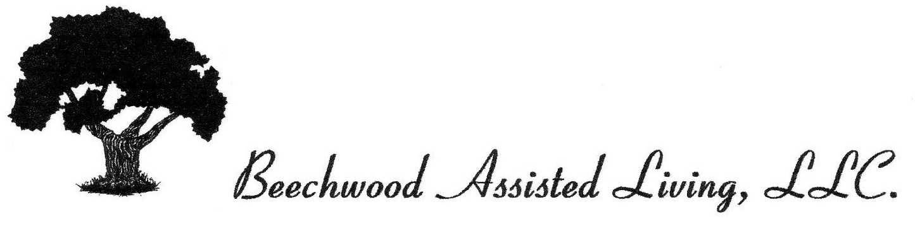

Date: ___________________, 20______

Dear M____________________________

Beechwood Assisted Living is offering our residents an opportunity to become protected against influenza (flu) during the upcoming season.

Due to the age and infirmity of our residents, they are at particular risk for the flu. We need the participation of the majority of our residents to achieve protection against a local epidemic. We are setting up a program to administer the vaccine to all of the residents who desire this service with physician approval.

We also encourage frequent visitors to see their physician for a vaccination. For the protection of all our residents, please do not visit if you have any flu symptoms.

Please indicate below your preference by checking one line and signing where indicated and return same by _____________________.

Sincerely,

Bruce K. Feuerstein,
Director

_______________________________________________________
Resident’s Name (please print)

______I want the above named resident to receive the Influenza Vaccine annually as administered by the facility program unless notified otherwise.

_______I do not want the above named resident tor receive the Influenza Vaccine while at this facility.

Signed__________________________________________ Date____________________________
Resident or Responsible Party for the
above-named resident.

